Table 3. The remaining 22 features of the full feature vector
# | Feature name | Description | Distinguished digits | Examples
14. | ‘White_Bottom’ | Count of the white pixels contained between the bottom corner of the bounding box until black pixels are encountered. | 6,8,9 versus rest | 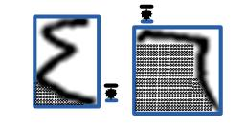
15. | 'White_Right’ | Count of the white pixels contained between the right corner of the bounding box until black pixels are encountered. | 2,3,4 versus rest | 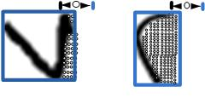
16. | 'White_Top' | Count of the white pixels contained between the top corner of the bounding box until black pixels are encountered. | 3,7 versus rest | 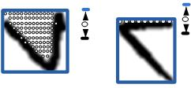
17. | 'Max_Left_Transition' | Maximum distance between the column positions of the starting black pixels in any two consecutive rows inside the bounding box. | 4,6,9 versus rest | 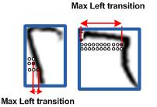
18. | 'Left_Transition_Location' | Row location of the above maximum left transition. | 6 versus 4,9 | 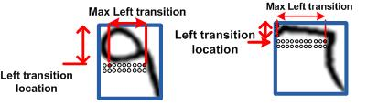
19. | 'Max_Right_Transition' | Maximum distance between the column positions of the last black pixels in any two consecutive rows inside the bounding box. | 2,3,4 versus rest | 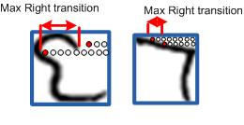
20. | 'Right_Transition_Location' | Row location of the above maximum right transition. | 2 versus 3 | 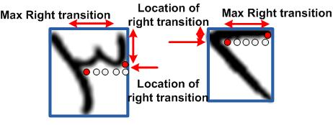
21. | 'Sum_Negative_Transitions' | Number of rows in which the last black pixel is in a column to the left of the column of the last black pixel in the previous row. | 7 versus rest | 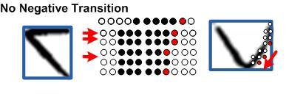
22. | 'Sum_Positive_Transitions' | Number of rows in which the last black pixel is in a column to the right of the column of the last black pixel in the previous row. | 7 versus rest | 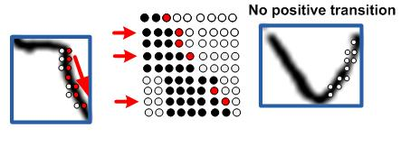
23. | 'Sum_Zero_Transitions' | Number of rows in which the last black pixel is in the same column as the last black pixel in the previous row. | 2,6,9 versus rest | 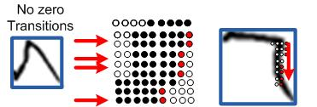
24. | 'Sum_Big_Transitions' | Number of rows in which the last black pixel is in a column more than three pixels to the right of the column of the last black pixel in the previous row. | 4 versus rest | 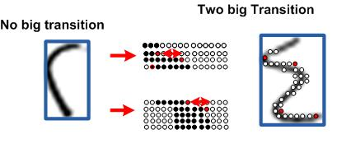
25. | 'Width_Lower_Half' | Number of rows in the lower half of the bounding box that are less than five black pixels. | 2,3,4,6,9 versus 5,7,8 | 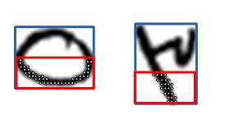
26. | 'Small_Width' | Number of rows in the bounding box that have black pixels spanning less than half the width of the bounding box. | 2,3,4 versus rest | 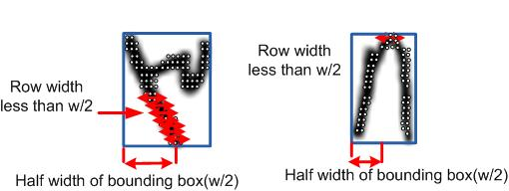
27. | 'Large_Width' | Number of rows in the bounding box that have black pixels spanning more than one quarter of the width of the bounding box. | 5,7,8 versus rest | 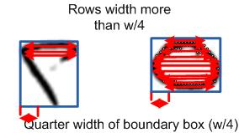
28. | 'Black_Top' | Count of the average number of black pixels in the top three rows of the bounding box. | 2 versus 3 | 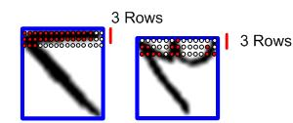
29. | 'Black_Bottom' | Count of the average number of black pixels in the bottom three rows of the bounding box. | 2 versus 4 | 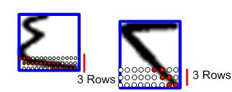
30. | 'Black_Left' | Count of the average number of black pixels in the three columns at the left side of the bounding box. | 2 versus 6 | 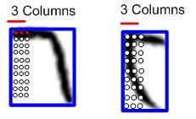
31. | 'Black_Right' | Count of the average number of black pixels in the three columns at the right side of the bounding box. | 2 versus 6 | 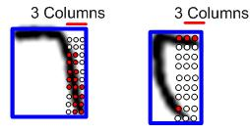
32. | 'Top_Black_Turns ' | Count of the number of times the locations of the starting black pixels in the columns of the bounding box decrease then increase. | 3 versus 7 | 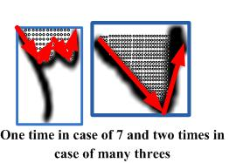
33. | 'Last_Black_Location' | The average row location of the last black pixels in the columns of the left half of the bounding box. | 6 versus 9 | 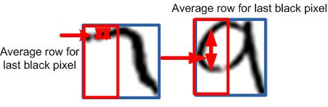
34. | 'Max_Downward_Transition' | Maximum distance between the row positions of the last black pixels in any two consecutive columns inside the bounding box. | 4,6,9 versus rest | 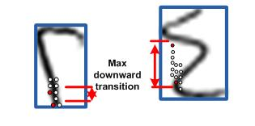
35. | 'Downward_Transition_Location' | Column location of the above maximum downward transition. | 4 versus 9 | 